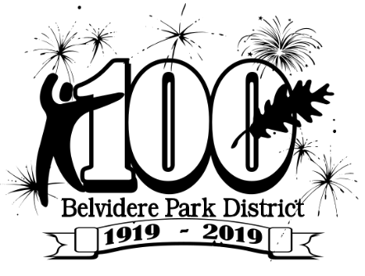
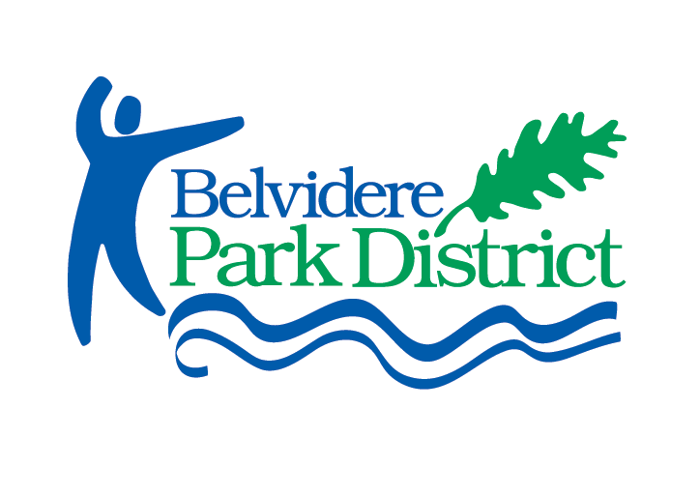

ordinance #16-03-01

CHAPTER IV - USE OF PARK

SECTION 4.01 RULES TO BE OBEYED
No person shall violate or disobey any rule of the District relating to the use and government of the park system. The Executive Director of the District or his authorized representatives may issue such rules and regulations as are necessary to insure public health and safety in the use and enjoyment of any and all park facilities, including but not limited to its park lands, swimming pool, and any other recreational facilities.

SECTION 4.02 LOCAL ORDINANCE COORDINATION
All public ordinances of all municipalities within which any part of the Belvidere Township Park District is located are hereby adopted by Belvidere Township Park District insofar as the same are applicable to, and not in conflict with these ordinances, for the regulations of the use of that portion of the parks and park facilities of Belvidere Township Park District located within the territorial limits of such respective municipalities. Said municipal ordinance within the portion of the Park District located within said respective municipalities shall be deemed to be addition to the provisions of these ordinances.

SECTION 4.03 PARK CLOSING HOURS
The parks of the District shall be closed from 10:00 pm until 6:00 a.m. the following morning, except with the written consent of the Executive Director. No person or property of any kind shall remain in the parks after closing time unless written permission has been granted by the Executive Director for later hours. (Class A)

SECTION 4.04 PERMITS
a. Any act prohibited under this code or any other ordinance or rule of the District, provided such act not be otherwise prohibited by State or Federal law, shall be lawful to the extent authorized or permitted under the provisions of a permit issued or written permission granted by the District.
b. Permits shall be issued and written permission granted only upon the payment of such fees and deposits as may be established by the District. All terms for the issuance of the permits and granting of written permission must be strictly complied with, and any violation shall be grounds for revocation of said permit.
c. Any group shall be allowed to reserve designated areas in certain parks by written permission of the Executive Director.
d. Large groups over 20 people shall be required to notify and seek permission to gather by the Park District. This may be accomplished by renting reservable facilities or a written request to the Executive Director to gather without renting reservable or non-reservable facilities. The District reserves the right to accept or deny the request to best serve all users of the facility and may request a certificate of insurance naming the Park District as additional insured based on the nature of the use. (Class A)
e. No person shall sell, consume, or possess alcoholic beverages upon any property of the District except upon written permission issued by the Executive Director upon prior application Therefore by such not-for-profit charitable or community organization whose membership is open to the general public or governmental entities who shall:
- Provide adequate security and police protection for the event for which a permit to dispense alcoholic beverage shall be sought;
- Provide to the Executive Director evidence of dram shop insurance; 3. Agree to indemnify and hold harmless Belvidere Township Park District from any claims or liability which might arise out of the event or the dispensing or consumption of alcoholic beverage;
- Provide adequate clean-up and maintenance service upon the conclusion of the event or reimburse the Park District for such service; and
- Provide or dispense alcoholic beverage only in connection with an event presented for the enjoyment of the general public rather than a purely private group. Such permit shall authorize only the sale, distribution, or consumption or possession of wine and beer and of no other alcoholic beverages. (Class A)

SECTION 4.05 UNLAWFUL USE OF PERMIT
It is unlawful within the Belvidere Township Park District for any person:
- To display or cause or permit to be displayed or have in his possession any cancelled, revoked, suspended, fictitious, or fraudulently altered permit;
- To lend his permit to any other person or knowingly allow the use thereof by another;
- To display or represent as his own, any permit not issued to him;
- To permit any unlawful use of a permit issued to him.
(Class B)

SECTION 4.06 PARADES AND MEETINGS
No person or persons shall hold or participate in any procession, public meeting, gathering or parade within the park system without having first obtained written permission to do so from the Executive Director (Class B)

SECTION 4.07 REFUSE
No person shall deposit or leave any garbage, tree, shrub, or grass trimmings or clippings, refuse or other material of any kind on the park system grounds or waters. Paper, glass, cans, garbage and other refuse of every kind resulting from picnics or other proper use of the park system shall be deposited in receptacles provided for that purpose, and no person shall litter, suffer, or cause the park system to be littered in any way. (Class B)

SECTION 4.075 GRAFFITI PROHIBITED
- It shall be unlawful for any person to write, paint, draw or otherwise mark upon any wall, rock, bridge, building, fence, gate or other structure, tree or other real or personal property, located upon property owned and controlled by the District any drawing, inscription, figure or mark of the type commonly known and referred to as graffiti.
- The District Executive Director or his designee may by written permit, allow writing, painting, drawing or other marking upon specified structures or property of the District, at specified times and for specified purposes, upon such reasonable terms and conditions as he may determine, which conditions shall be evenly and fairly applied.
- Penalty – A violation of this Section shall constitute a Class C offense under the Penal Ordinances of the District.

SECTION 4.08 TREES AND SHRUBS
- No person shall cut, break, or in any way injure or deface any tree, shrub, plant, flower, turf, or any of the buildings or other structures and properties, or dig into the soil or into any road, park, parkway or playground within the Belvidere Township Park District without written permission of the Executive Director. (Class B)
- No person shall cut, quarter or remove any dying, dead or downed trees or shrubs from the Belvidere Township Park District property without written permission of the Executive Director. (Class B)

SECTION 4.09 ANIMALS
- No person shall hunt, trap, catch, wound or kill or treat cruelly, or attempt to hunt, trap, catch or wound or kill any bird or animal in any park. (Class B)
- No person shall bring a dog or cat within the park system controlled by the District, unless properly leashed and under control at all times. It is also unlawful for any dog owner to allow a dog under his control to deposit solid waste or dung without immediately removing such waste in a proper container. (Class A)
- No person shall lead, ride or allow to be loose upon District property, any horse, pony or other riding animal except in areas designated for riding and by written permission of the Executive Director. (Class A)
- Any animal found within the park system in violation of this section may be apprehended, removed to the animal shelter, public pound or any other place, provided for that purpose and impounded, all at the expense of the owner. (Class C)

SECTION 4.10 FIRES
No person shall light or make use of any fire in the park system except at such places as may be established for such purposes and then only under such rules as may be prescribed therefore. Every fire shall be continuously under the care and direction of a competent person from the time is it kindled until it is completely extinguished. (Class A)

SECTION 4.105 SMOKING PROHIBITED
- It shall be unlawful for any person who has not attained the age of eighteen (18) years to smoke or possess upon the parks and lands of the District or other areas subject to the jurisdiction and control of the District, cigarettes, cigars, pipes or other types of tobacco;
- Penalty, A violation of this Section shall constitute a Class A offense under the Penal Ordinances of the District. A second violation of this Section within a one (1) year period shall constitute a Class B offense under the Penal Ordinances of the District. A third and subsequent violation of this Section within a one (1) year period shall constitute a Class C offense under the Penal Ordinances of the District.

SECTION 4.11 CAMPING
No person shall be permitted to stop and camp in parks of the Belvidere Township Park District without first having obtained written permission to do so by the Executive Director. (Class A)

SECTION 4.12 RESTRICTED AREAS
No person shall enter upon any portion of the park system where persons are prohibited by the District as indicated by sign or notice. No person shall enter or attempt to enter any building or area in the park system when it is closed to the public or scheduled for a specific group or activity, unless invited by same. (Class A)

SECTION 4.13 FIGHTS – DISORDERLY CONDUCT
- No person within the limits of the Belvidere Township Park District or its playgrounds shall engage in, instigate, cause or procure any prize fight, dog fight, cock fight, or any public or private fighting.
- No person shall do any act in such unreasonable manner as to alarm or disturb another and to provoke a breach of the peace while within property of the Belvidere Township Park District. (Class B)

SECTION 4.14 WEAPONS, MISSILES AND FIREWORKS
No person or organization shall bring, carry, or use in any way knives, firearms, or other weapons of any kind, or any fireworks or other explosive substance of any kind into the park system without the written permission of the Executive Director. No person shall throw, cast, or shoot arrows, stones, or other missiles of any kind within the park system except at such places and times as the District may designate for such purposes. (Class B)

SECTION 4.15 HAWKING, PEDDLING AND SELLING
No person shall hawk, peddle or sell or attempt to hawk, peddle or sell any goods, wares or merchandise of any kind or nature within said parks or playgrounds without first having obtained written permission of the Executive Director to do so. (Class A)

SECTION 4.16 GAMBLING
No person or organization shall engage in gambling or any gambling-related activity within the Belvidere Township Park District. (Class A) Gambling for purposes of the above includes the following:
- A game of chance or skill for money or for other things of value unless otherwise declared legal by the laws of the State of Illinois.
- Wagering upon the result of any game, contest or any political nomination, appointment or election.
- Operating, keeping, owning, using, purchasing, exhibiting, renting, selling, bargaining for the sale or lease of, manufacturing or distributing any gambling device.
- Knowingly owning or possessing any book, instrument or apparatus by means of which bets or wages have been or are recorded or registered or knowingly possessing of any money which has been received in the course of a bet or wager.
- Selling pools upon the result of any game or contest of skill or chance, political nomination, appointment or election.
- Setting up or promoting any lottery or selling, offering to sell or transferring any ticket or share of any lottery unless specifically provided by the laws of the State of Illinois.
- Setting up or promoting any policy game or selling, offering to sell or knowingly possessing or transferring any policy ticket, slip, record, document or other similar device.

SECTION 4.17 SOUND AMPLIFICATION
No person within the Belvidere Township Park District system shall play or operate any sound amplification device including radios, television sets, phonographs, tape decks, public address systems, amplified musical instruments and the like or operate any other energy amplification device in a manner which may reasonably be expected to annoy other persons in the parks. (Class A)

SECTION 4.18 ADVERTISING
No person shall display any placard or advertisement of any kind in any park, nor shall any person distribute, cast, throw, or place any handbill, pamphlet, circular, advertisement or notice of any kind, nor post, stencil or otherwise affix any notice or bills, advertisements or other papers upon any structure or thing in or about any park. (Class A)

SECTION 4.19 MOTORIZED VEHICLES
- Keep to Drives No person shall drive any automobile, truck, motorcycle, or other motorized vehicle within any of the parks of the District except upon the designated roadways and parking areas provided for driving or parking the same, except Park District employees in the performance of their duties. (Class B)
- Trucks No person not having business in the Park District system shall drive any vehicle having a gross weight of 10,000 lbs. or more upon any of the driveways of any of the parks of the District without written permission of the Executive Director. (Class B)
- Speed Restrictions
  - No vehicle may be driven upon any roadway within the Belvidere Township Park District at a speed which is greater than is reasonable and proper with regard to traffic conditions and the use of the highway, or which endangers the safety of any person or property. The fact that the speed of the vehicle does not exceed the applicable maximum speed limit does not relieve the driver from the duty to decrease speed when approaching and crossing an intersection, when approaching and going around a curve, when approaching a hill crest, when traveling upon any narrow or winding roadway, or when special hazard exists with respect to pedestrians or other traffic or by reason of weather or highway conditions. Speed must be decreased as may be necessary to avoid colliding with any person or vehicle on or entering the roadway in compliance with legal requirements and the duty of all persons to use due care. (Class B)
  - No person may drive a vehicle upon any roadway of the Belvidere Township Park District System at a speed which is greater than 15 mph. (Class B)
  - In every charge of violation of this section by failure to observe an applicable speed limit, the complaint shall specify the speed at which the defendant is alleged to have driven, and the speed limit which is applicable at the place of the alleged violation.
- One Way Traffic No vehicle may be driven upon any one-way designated roadway within the Belvidere Township Park District contrary to the established direction, except Park District vehicles in the performance of their duties. (Class B)
- Designated Parking Areas No person shall park any vehicle in designated parking areas of the District beyond the normal closing hour of the park system at Dusk except where an individual is attending a function where written permission has been granted for a later closing hour by the Executive Director or specified therein. (Class A)
- Parking, Standing or Stopping Illegally No person shall park, stand or otherwise stop a vehicle within any Park of the District, except when necessary to avoid conflict with other traffic or in compliance with the direction of a police officer or traffic control device, in any of the following places: (Class A)
  - On lawn areas and grounds.
  - In front of public or private driveways or loading zones.
  - In any position to block another car legally parked.
  - At any place where official signs prohibiting parking entirely or prohibiting parking for more than a specified period have been posted by the District.
  - In any park beyond the normal closing hour of Dusk.
  - In any position which obstructs or interferes with the travel of other vehicles on a roadway or the use of any park facility within the District.
  - Within fifteen (15) feet of a fire hydrant or a traffic control signal or sign.
- Unattended Motor Vehicles No person driving or in charge of a motor vehicle within the Belvidere Township Park District shall permit it to stand unattended without first stopping the engine and removing the ignition key, and when standing upon any perceptible grade without effectively setting the brake and turning the front vehicle wheels to the curb or side of the road. (Class A)
- Snowmobiles (Class B)1. It shall be unlawful for any person to operate any snowmobile in or on any portion of district properties.
- Impounding of Vehicles Any vehicle parked or standing within the park system in violation of any law, ordinance, or rule is hereby declared to be a public nuisance. Such vehicle may be removed and impounded and the owner or person entitled to possession of the vehicle shall pay all charges and expenses arising out of any action taken hereunder. (Class C)
- Bicycles All provisions of the State of Illinois and City of Belvidere code pertaining to bicycles shall apply to all bicycles and to their owners and operators while on park property.
  - It shall be unlawful to ride a bicycle on any ground or turf area on any park property. Bicycles shall be permitted on all roadways, paths, sidewalks and parking lots that are paved or graveled.
  - It shall be unlawful to ride a bicycle across any pedestrian bridge. Any person wishing to cross a pedestrian bridge must first disembark completely from the bicycle and shall walk alongside the bicycle and obey all laws governing pedestrians.

SECTION 4.20 PENALTIES
  - Eviction – Any person violating any of the provisions of this chapter may be forthwith evicted from the parks or other places under the control of the Park District.
  - Penalties – Any person violating any of the provisions of this chapter shall, upon conviction, pay a fine of not less than $100.00 nor more than $1,000.00 to be recovered in a manner and form provided by law.
  - Any person accused of violation of any provision of this chapter may settle the claim against him by paying to the Belvidere Township Park District the sum as described below:
    - Class A Fines: Not less than $100.00 per offense ($50.00 if paid within 5 days of issuance of citation);
    - Class B Fines: Not less than $150.00 per offense ($75.00 if paid within 5 days of issuance of citation);
    - Class C Fines: Not less than $250.00 per offense ($125.00 if paid within 5 days of citation),
However, no such settlement may be made once a complaint has been filed with the Circuit Clerk
  - The penalties set forth in Subsection C above shall be deemed minimum penalties and in appropriate cases the District may seek higher penalties not to exceed the maximum amount allowed and provided by law.

SECTION 4.21 ISSUANCE OF CITATION
The Park District Executive Director shall designate the proper persons or authorities that have the power to issue complaints or citations regarding the enforcement of all ordinances.

