Belvidere Park District

NOTICE OF BID

1. Sealed bids for installing playground equipment, removal of existing equipment, and other site work for Belvidere Park District, will be received until 10:00 A.M. on January 31st, 2023, at which time they will be publicly opened and read aloud. Bid should be addressed to Jonathan Cudzewicz , Belvidere Park District 1006 W Lincoln Ave Belvidere , IL 61008

Any bids received after this date and time will be returned unopened.

I. Instructions to Bidders

1. Bids shall be submitted in a sealed envelope and clearly marked:

SEALED BID
DOTY PLAYGROUND EQUIPMENT INSTALLATION

2. The successful bidder will be selected based on the District's evaluation of each bidder, reference checks, and the final approval by the Park District Board of Commissioners.
The Park District reserves the right to reject any or all bids and to waive informalities to serve the best interest of the Park District. Such decisions shall be final and not subject to recourse.

3. No bids may be withdrawn after the official opening. All bids
submitted must be valid for a minimum period of sixty (90) days after
the date set for the bid opening.

Page 1

4. Bidder’s signature on the Bid Offer Form will be construed as
acceptance of and willingness to comply with all provisions of the
acts of the General Assembly of the State of Illinois relating to wages
of laborers, sexual harassment, drug free workplace, preference to citizens of the United States and residents of the State of Illinois, and discrimination and intimidation of employees. Provisions of said acts are hereby incorporated by reference and become a part of this proposal and specification.

- The Park District is not subject to Sales Tax, Federal Excise Tax, or Illinois Retailers Occupational Tax.

- All play equipment and all play equipment components will be purchased from NuToys Leisure Products and provided to the contractor by the Park District.

II. Scope of Work The following tasks are included in the base bid:

1. Install new Landscape Structures playground equipment for Doty Park in strict accordance with the attached specifications and plans. Equipment provided by owner. Please note the Lunar Blast and the Global motion shown on the plan and 3D are existing equipment and not to be disturbed.

2. Remove existing 2 bay arch bay swing, and reinstall with an additional bay in the location noted on the drawing.

3. Contractor shall exercise care so as not to damage existing grass, walks, or other Park District property during the performance of its contract. Contractor shall repair or replace any damaged grass or material, should damage occur during construction. The Contractor shall be responsible for removing and disposing all debris and packing material from the job site.

4. Supplier shall inspect playground equipment after completion of installation and shall notify the Park District of any installation errors or omissions. The certification letter shall state that there are no installation errors if none are found.

The following tasks are to be proposed as alternate item:

- Remove existing 109 lineal feet of existing concrete curbing
Supply and install 303 lineal feet of concrete curb 8’’ x 18’’ per the drawing below.
- Supply and install an additional 160 cubic yards of certified playground mulch.

III. Insurance

The Contractor shall carry Liability Insurance with a minimum coverage of $1,000,000.00 including Umbrella covering in the following categories:

Personal Injury
Property Damage
Vehicles
Completed Operations

The Contractor shall also be covered by Workman’s Compensation Insurance that meets Illinois limits.

Manufacturers of playground equipment shall carry Product Liability insurance with limits of no less than $10 million, including umbrella policy.

Certificates of Insurance showing such coverage shall be furnished with the bid.

IV. Safety

Contractor shall fence in the area during construction to prevent citizen use during construction.

V. References

Contractor shall list the names, addresses, and phone numbers of at least five (5) references where work of a similar nature and scope has been performed.

VI. Completion Date

Project shall be completed as soon as possible but no later than May 19th, 2023.

VII. Payment

The Owner shall make final payment within thirty (30) days after completion and acceptance of the work. No payment will be made to the Contractor until final waivers of lien have been submitted, assuring the Park District that all materials, including play equipment and concrete used on this project, have been fully paid for.

VII. Equipment List

2 | 177333A |  | arch Swing Frame Additional Bay 8' Beam

 |  |  | DOTY PARK
 |  |  | BELVIDERE, IL
 |  |  | OPTION 1
 |  |  | PLAYBOOSTER
QTY. | NO. |  | DESCRIPTION | UNIT PRICE
 |  |  | PlayBooster Component System 5-12
1 | 172666B |  | Corkscrew Climber w/Recycled Wood-Grain Handholds 72"Dk DB
1 | 271906A |  | Wood Plank Ladder w/Wood-Grain Handholds 72" Deck DB
1 | 146812A |  | Sky Rail Climber 72"Dk DB¹
1 | 152907D |  | Deck Link w/Barriers Steel end panels 4 Steps
2 | CP000151A |  | DTR PB Playodyssey 41i Tall Wire Mesh Upper Barrier | $ 2,116
1 | CP000149A |  | DTR PB Playodyssey Treehouse Corrugated Steel Roof
1 | CP000148A |  | DTR PB Playodyssey Treehouse Tower
1 | 152911A |  | Curved Transfer Module Left 32"Dk DB
1 | 111231A |  | Triangular Tenderdeck
2 | 116244A |  | Pipe Barrier Above Deck | 761
1 | 169319A |  | Recycled Wood-Grain Lumber Panel
3 | 120314A |  | Wire Barrier Above Deck | 835
2 | 165824A |  | 12' Tower Bubble Panel | 1,901
2 | 165960A |  | 12' Tower Pipe Barrier | 1,381
1 | 165780B |  | 12' Tower SlideWinder2 w/Barrier
1 | 222710B |  | 12' Tower WhooshWinder Slide w/Barrier
1 | 118089A |  | Loop Seat
1 | 111404F |  | 108"Alum Post DB
2 | 111404E |  | 116"Alum Post DB | 373
1 | 271761A |  | Alpine Slide 72" Deck DB¹
1 | 182503C |  | Welcome Sign (LSI Provided) Ages 5-12 years Direct Bury
 |  |  | SUBTOTAL
 |  |  | PlayBooster Component System 2-5
1 | 145839A |  | Critter Canyon DB
1 | CP000184A |  | DTR PB Bee Pipe Barrier Above Deck
3 | 121948A |  | Kick Plate 8"Rise | $ 142
3 | 111228A |  | Square Tenderdeck | 1,250
1 | 185852A |  | Transfer Step w/2 Handloops DB
1 | 111231A |  | Triangular Tenderdeck
1 | 115236A |  | Ball Maze Panel Above Deck
1 | 217909A |  | DigiFuse Barrier Panel Above Deck Insects-Bee Anatomy/Critters - 000000006
1 | 116244B |  | Pipe Barrier w/Wheel Above Deck
1 | 115254A |  | Storefront Panel
1 | 120901A |  | Grab Bar
1 | 111404G |  | 100"Alum Post DB
2 | 111404F |  | 108"Alum Post DB
1 | 111403T |  | 110"Steel Post For Roof DB
2 | 111404E |  | 116"Alum Post DB
2 | 111403R |  | 126"Steel Post For Roof DB
1 | 111404H |  | 92"Alum Post DB
3 | 212256A |  | Flower Accent Topper
1 | 123337A |  | Single Slide 40"Dk DB
1 | 129042B |  | Offset Crawl Tunnel 24"Offset Deck To Ground
1 | 111331A |  | Tunnel Support 8"Dk w/Alum Posts DB
1 | 182503A |  | Welcome Sign (LSI Provided) Ages 2-5 years Direct Bury
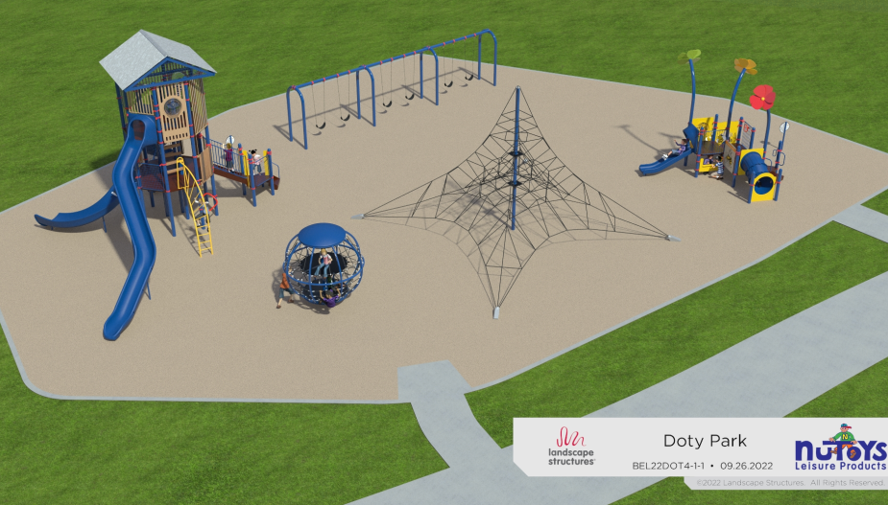
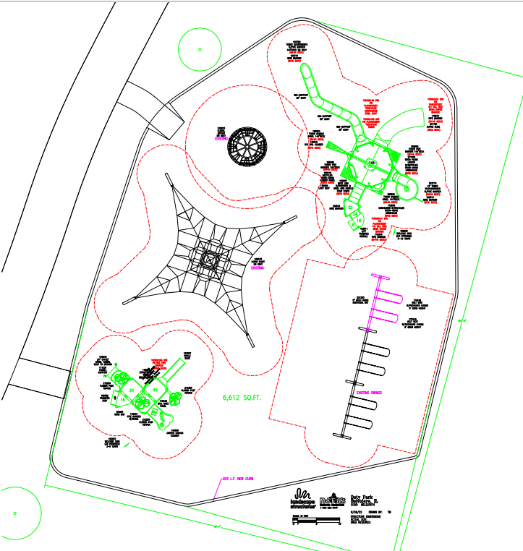

PRODUCT

MANUFACTURERS

Manufacturers:

Landscape Structures, 601 7th Street South, Delano, MN 55328. Locally represented by NuToys Leisure Products, 915 Hillgrove, LaGrange, IL 60525, (708)579-9055 or (800) 526-6197.

EXECUTION

EXAMINATION

Examine the area and conditions of the site. Verify safety zones of all equipment before setting posts in concrete footing.

Proceed with installation only after unsatisfactory conditions have been corrected.

PREPARATION

Verify that all equipment needed for installation has been sent correctly.

INSTALLATION:

Conform strictly to manufacturer’s instructions. Use only experience personnel trained in play equipment installation.

Provide all concrete footings as required. It is the contractor’s responsibility to adjust drainage pipe or other new utility locations to accommodate the equipment footings.

FIELD QUALITY CONTROL

Contractor shall contact manufacturer’s representative to review playground installation for accuracy.

Contractor shall notify Architect to review installation for review of overall conformance to specifications and workmanship.

ADJUSTING

Ensure that adjustments required by inspections are corrected to owner’s satisfaction.

CLEANING AND PROTECTION

Contractor is responsible to protect equipment until accepted by owner.

Consult manufacturer’s cleaning instructions.

END OF SECTION

Bid form page 1

VIII. Bid Offer Form

Having read all sections of the bid documents, plans, and equipment specifications and familiarized ourselves with the existing conditions which might affect the work, we are pleased to bid as follows on all the work associated with this project as described above.

Base Bid:
Includes all the work described in Scope of Work section above.

$_ _________________
Alternate Bid Items:

1. Removal and installation of concrete
$_____________________

2. Install certified playground mulch
$_____________________

Bid form Page 2

CONTRACTOR’S REFERENCES

Below are listed at least five (5) references where we have performed work of a similar nature and scope to that described in this bid.

1. _________________________________
_________________________________
_________________________________
_________________________________

2. _________________________________
_________________________________
_________________________________
_________________________________

3. _________________________________
_________________________________
_________________________________
_________________________________

4. _________________________________
_________________________________
_________________________________
_________________________________

5. _________________________________
_________________________________
_________________________________
_________________________________

Bid form Page 3

DATED THIS _______________ day of _________________, 2023

____________________________
Company name of Bidder (print) (a) Individual ( )
(b) Partnership ( )
(c) Corporation ( )
____________________________
Full name of Bidder (Signature)

____________________________
Full name of Bidder (Print)

____________________________
Official Title

____________________________
Street Address

____________________________ ______________________
City State Zip Phone Number

______________________
Fax Number

______________________
E-Mail

